**Burndown Chart**

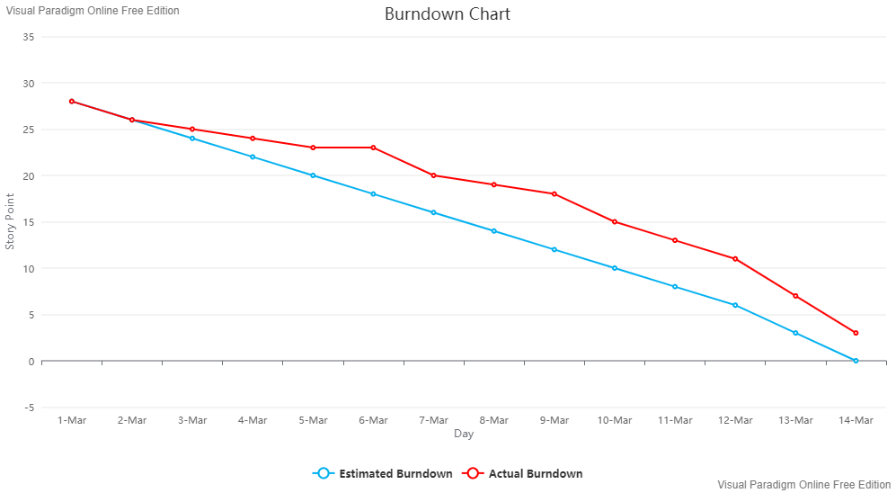

Figure 1: Sprint 1 Burndown chart

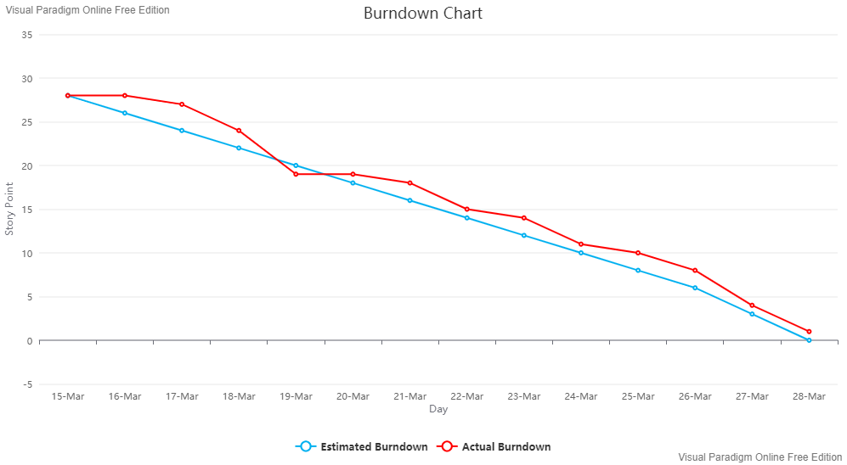

Figure 2: Sprint 2 Burndown Chart

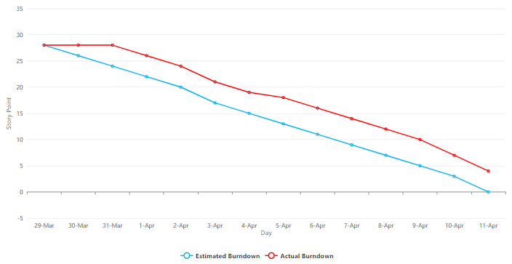

Figure 3: Sprint 3 Burndown Chart